Cloud Lab 4

Installing Istio:

Namespace label:



*Check & Install Gateway API CRDs* In PowerShell:

Deploy Bookinfo Sample Application:

Check Bookinfo Services

Check Bookinfo Pods

Validate Bookinfo Application Inside Cluster

Create Bookinfo Gateway

Annotate Gateway to ClusterIP

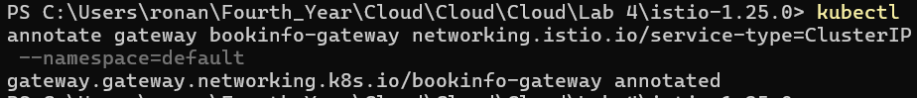

Check Gateway Status

Port Forward to Bookinfo Gateway

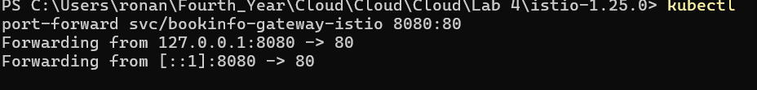

*Deploy Istio Addons*

Check Kiali Deployment Rollout

Open Kiali Dashboard



